Witam serdecznie kochane przedszkolaki, dzisiaj zapraszam was do zabawy językowej z rymowanką.
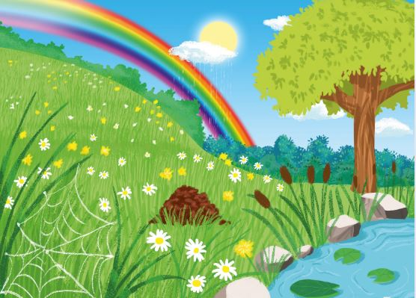
Where is the cricket?
Where could it be?
Over the rainbow?
Under the tree?
On the big hill?
In the green grass?
The cricket is next to the lake
It’s looking at us.

Where is the ladybird?
Where could it be?
Over the rainbow?
Under the tree?
On the big hill?
In the green grass?
The ladybird is next to the cricket
It’s looking at us.

Where is the ant?
Where could it be?
Over the rainbow?
Under the tree?
On the big hill?
In the green grass?
The ant is next to the ladybird
It’s looking at us.

Where is the bee?
Where could it be?
Over the rainbow?
Under the tree?
On the big hill?
In the green grass?
The bee is next to the ant
It’s looking at us.

Where is the spider ?
Where could it be?
Over the rainbow?
Under the tree?
On the big hill?
In the green grass?
The spider is next to the bee
It’s looking at us.

Where is the caterpillar?
Where could it be?
Over the rainbow?
Under the tree?
On the big hill?
In the green grass?
The caterpillar is next to the spider
It’s looking at us.

Where is the butterfly?
Where could it be?
Over the rainbow?
Under the tree?
On the big hill?
In the green grass?
The butterfly is next to the caterpillar
It’s looking at us.

SŁOWNICTWO:
Cricket – świerszcz
Ladybird – biedronka
ant - mrówka
bee - psczoła
spider - pająk
caterpillar - gąsienica
butterfly – motyl
is next to – znajduje się/jest obok
cricket is next to the lake – świerszcz obok jeziora
ladybird is next to the cricket – biedronka obok świerscza
ant is next to the ladybird – mrówka obok biedronki
bee is next to the ant – pszczoła obok mrówki
spider is next to the bee – pająk obok pszczoły
caterpillar is next to the spider – gąsienica obok pająka
butterfly is next to the caterpillar – motyl obok gąsienicy
where is – gdzie jest
over – ponad
rainbow – tęcza
under – pod
tree – drzewo
on – na
big – duży
hill – wzgórze
rain - deszcz
grass – trawa
green – zielony
red – czerwpny
blue – niebieski
yellow – żółty
purple – fioletowy
orange – pomarańczowy

Po skończonej pracy chętne osoby zapraszam do stworzenia poprzez namalowanie kredkami lub farbami pięknej łąki na której znajdą się: cricket, ladybird, ant, bee, spider, caterpillar and butterfly i przesłanie prac na adres mailowy przedszkola:
p124@edu.um.warszawa.pl

Have a nice work

